**DIGITAL SYSTEMS**

**PRACTICUM 11**



**By:**

**ARIA WIDIYO NOVIYANTO**

**NIM: L200183043**

**INFORMATION TECHNOLOGY**

**FACULTY OF COMMUNICATION AND INFORMATICS**

**UNIVERSITY OF MUHAMMADIYAH SURAKARTA**

**Experiment 1**

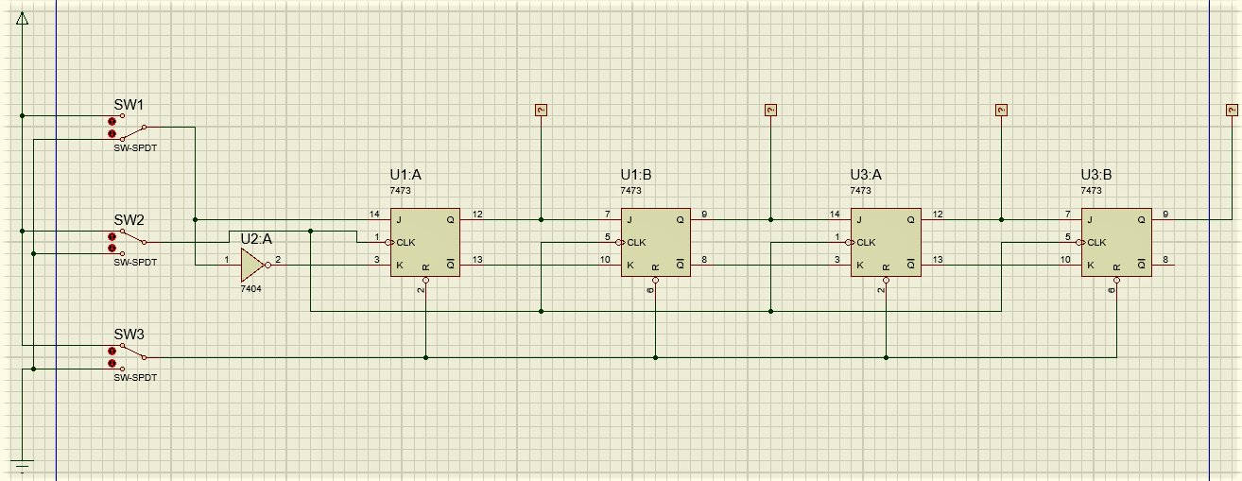

Picture 1.1. 4-bit register circuit

1. Reset the shift register by activating the SW3 switch (open).
2. Set SW1 switch in binary position 1.
3. Give 4 shear pulses (0-1) through the SW2 switch, observe the register state through the PROBE condition.
4. Record the binary number of the contents of the register after 4 slide pulses have been given.

ABCD = 1111

1. Next, the SW1 switch sets at binary position 0, and gives 4 pieces of sliding pulses through the SW2 switch. And record the contents of the register.

ABCD = 0000

1. Using SW1 switch and SW2 switch.

Give the load on the shift register step by step through the procedure below:

SW1 = 1, then give one pulse from the SW2 switch

SW1 = 0, then give one pulse from the SW2 switch

SW1 = 1, then give one pulse from the SW2 switch

SW1 = 0, then give one pulse from the SW2 switch

1. After that, observe the PROBE state and write a decimal number that is equivalent to the binary number in the shift register.

Binary Numbers = 0101 Decimal Number = 5

**Experiment 2**

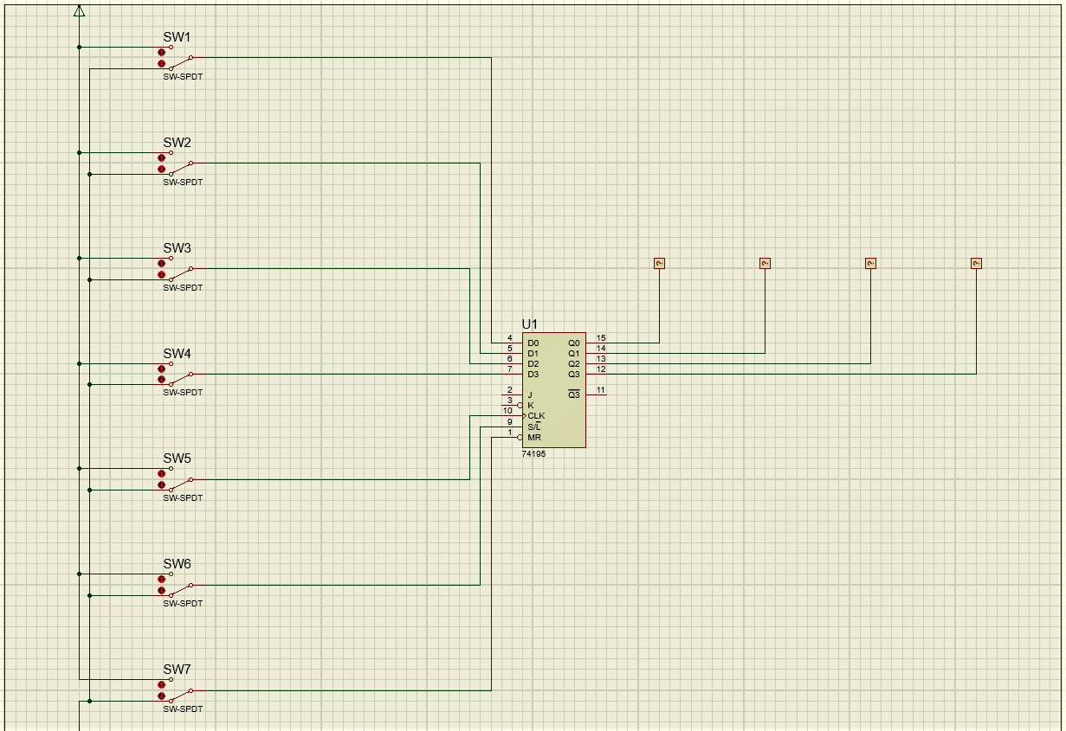

Picture 2.1. IC 74194 register circuit

1. SW1, SW2, SW3 and SW4 data switches are used as parallel data sources.

The SW5 switch is used to generate a sliding pulse.

The SW6 switch functions as the control mode for the circuit.

The SW7 switch functions as a data reset.

1. Set all data switches (SW1 to SW4) to binary 0.
2. Set SW6 switch to binary 0, then the SW5 switch is set to 0 then set to 1 again (give a clock pulse), then return the SW6 switch to binary 1 again. note the state of PROBE X1, X2, X3, and X4.
3. ABCD = 0000
4. Next, set all data switches (SW1 to SW4) to binary 1.
5. Set SW6 switch to binary 0, then the SW5 switch is set to 0 then set to 1 again (give a clock pulse), then return the SW6 switch to binary 1 again. note the state of PROBE X1, X2, X3, and X4.

ABCD = 1111

1. Give a clock pulse (set 0 then set 1 again) on the SW5 switch 4 times and observe the PROBE state after you enter 4 pulses slide into the shift-register and record the results below.

After pulse 1: ABCD = 0111

After pulse 2: ABCD = 1011

After pulse 3: ABCD = 0101

After pulse 4: ABCD = 1010

**Experiment 3**

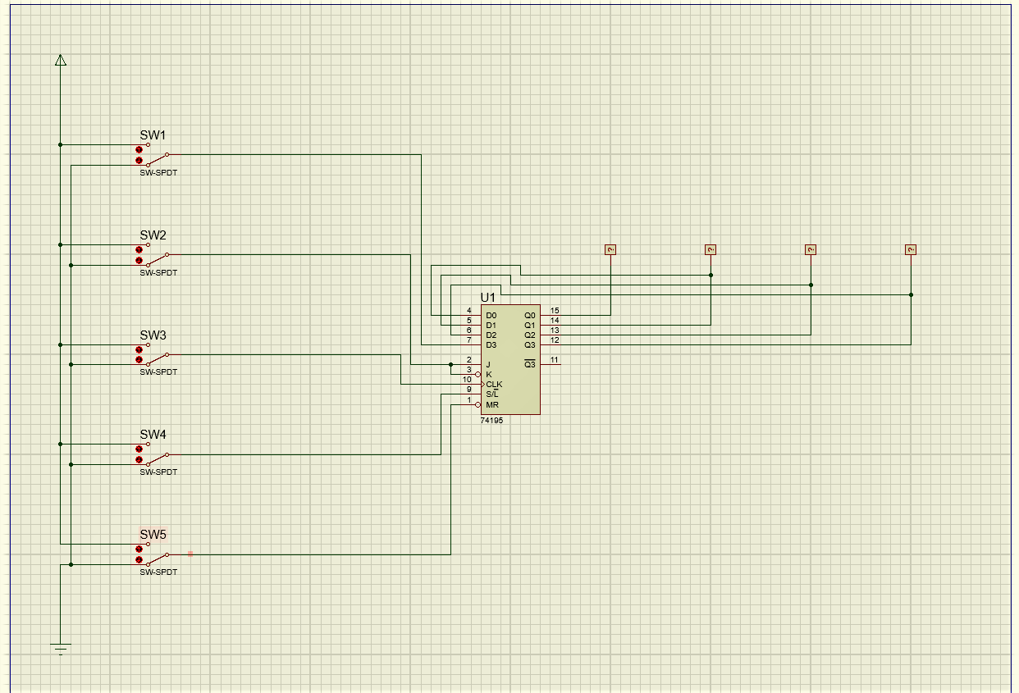Picture 3.1. Left shift register series 1

1. You can use the SW1 switch for serial data input in the left slide operation, the SW2 switch for serial data input in the right slide operation. The SW3 switch is used as the clock register source. The SW4 switch is used as the mode controller (control mode) of the circuit, which will determine the left or right sliding operation. SW5 switch to reset registers.
2. run the simulation.
3. Set the switch in the following binary conditions:

SW1 = 0; SW2 = 0; SW3 = 1; SW4 = 0; SW5 = 1

1. To reset data, give input one pulse on SW5 (0 - 1).
2. Set SW1 to binary value 1.
3. Give pulses to the SW3 switch 5 times then record the results at the output.

before the pulse is given: ABCD = 0000

after pulse 1: ABCD = 0001

after pulse 2: ABCD = 0011

after pulse 3: ABCD = 0111

after pulse 4: ABCD = 1111

after pulse 5: ABCD = 1111

1. Set the switch in the following binary conditions:

SW1 = 0; SW2 = 0; SW3 = 1; SW4 = 1; SW5 = 1

1. To reset the data, give a pulse on the SW5 switch (set 0 then set 1 again).
2. Set the SW2 switch to binary 1.
3. Give pulses to the SW3 switch 5 times then record the results at the output.

Before Pulse Is Provided: ABCD = 0000

After pulse 1: ABCD = 1000

After pulse 2: ABCD = 0100

After pulse 3: ABCD = 1010

After pulse 4: ABCD = 0101

After pulse 5: ABCD = 1010

1. Set the switch in the following binary conditions:

SW1 = 0; SW2 = 0; SW3 = 1; SW4 = 0; SW5 = 1

1. To reset the data, give a pulse on the SW5 switch (set 0 then set 1 again).
2. Set the SW1 switch to binary 1.
3. Give pulses to the SW3 switch 1 time then record the results at the output.

Before Pulse Is Provided: ABCD = 0000

After Pulse Is Provided: ABCD = 0001

1. Set the SW1 switch to binary 0.
2. Give pulses to the SW3 switch 3 times then record the results at the output.

After pulse 1: ABCD = 0010

After pulse 2: ABCD = 0100

After pulse 3: ABCD = 1000

1. Set the SW4 switch to binary 0.
2. Give pulses to the SW3 switch 3 times then record the results at the output.

After pulse 1: ABCD = 0000

After pulse 2: ABCD = 0000

After pulse 3: ABCD = 0000

1. To better understand experiment 3, try to do other shift operations by changing the conditions of the SW1, SW2, SW3, SW4, and SW5 switches so that you understand the functions of each button.

**Experiment 4**



Picture 4.1. Left shift register 2

1. Set the switch in the following binary conditions:

SW1 = 0; SW2 = 0; SW3 = 1; SW4 = 0; SW5 = 1

To reset the data, give a pulse on the SW5 switch (set 0 then set 1 again).

1. Set the SW1 switch to binary 1.
2. Give pulses to the SW3 switch 2 times then record the results at the output.

Before Pulse Is Provided: ABCD = 0000 Decimal number = 0.

After pulse 1: ABCD = 0001 Decimal number = 1.

After pulse 2: ABCD = 0011 Decimal number = 3.

1. Set the SW1 switch to binary 0.
2. Give pulses to the SW3 switch 1 times then record the results at the output.

Before Pulse Is Provided: ABCD = 0110 Decimal number = 6.

1. Study the data you got in the procedure above! What is the relationship between the numbers obtained, when the register is loaded with data and the left shift operation register?

Answer: The number is obtained when SW5 is given input 1, the left sliding operation register applies if SW4 is given input 0, if SW1 is given input 1 when SW3 is given 1 pulse (from input 0 is changed to 1) it will produce output 1 on the right logicprobe. Likewise if SW1 is given input 0 then the output is 0. If SW3 is given 1 pulse again, the output will shift to the left.

1. What mathematical operation is formed by sliding left?

Answer: SW1. $\overline{SW4}$.SW5

1. Set the switch in the following binary conditions:

SW1 = 0; SW2 = 0; SW3 = 1; SW4 = 0; SW5 = 1.

1. To reset the data, give a pulse on the SW5 switch (set 0 then set 1 again).
2. Set the SW2 switch to binary 1.
3. Give pulses to the SW3 switch 1 times then record the results at the output.

Before Pulse Is Provided: ABCD = 0000 Decimal number = 0.

After Pulse Is Provided: ABCD = 1000 Decimal number = 8.

1. Set the SW2 switch to binary 0.
2. Give pulses to the SW3 switch 1 times then record the results at the output.

After Pulse Is Provided: ABCD = 1100 Decimal number = 12.

1. Set the SW2 switch to binary 1.
2. Give pulses to the SW3 switch 1 times then record the results at the output.

After Pulse Is Provided: ABCD = 0110 Decimal number = 6.

1. Give pulses to the SW3 switch 1 times then record the results at the output.

After Pulse Is Provided: ABCD = 1011 Decimal number = 11.

1. Learn the data that you have obtained, What is the relationship between the numbers obtained, when the register is loaded with data and the left shift operation register?

Answer: The number is obtained when SW5 is given input 1, the right sliding operation register applies if SW4 is given input 1, if SW2 is given input 1 when SW3 is given 1 pulse (from input 0 is changed to 1) it will produce output 1 on the left logicprobe. Likewise if SW2 is given input 0 then the output is 0. If SW3 is given 1 pulse again, the output will shift to the right.

1. What mathematical function is formed, when right sliding operation occurs?

Answer: SW2.SW4.SW5